Supplementary Material: Climate-driven changes predicted in zoonotic risk of arenaviral hemorrhagic fevers in South America

Pranav S. Kulkarni 1, Nuri Y. Flores-Perez 1, Marcela Uhart 2,3, Brian Bird 2, Christine K. Johnson 2, Pranav S. Pandit 1.

1 Department of Population Health and Reproduction, School of Veterinary Medicine, University of California, Davis

2 One Health Institute, School of Veterinary Medicine, University of California, Davis

3 Karen C. Drayer Wildlife Center, School of Veterinary Medicine, University of California, Davis

Section A. Force of infection for New World Arenaviruses (NWA) in South America

# 1.1 Deriving the model for Force of infection

The impact of climate change on the transmission risks for humans was studied by deriving the estimated rate of successful contact between susceptible humans and infectious rodents that resulted in transmission. This was termed as density dependent Force Of Infection (FOI). The exact mechanistic model for deriving the FOI for each of the geospatial coordinates and its connection with Species Distribution Models (SDMs) of rodent reservoirs of NWA is given by Equation S1:

$FOI=β\frac{H × R}{(H+R)}$ Eq. S1.1

Where, $FOI$ is the force of infection defined as the contact between susceptible humans and infectious rodents resulting in successful transmission of infection, $H$ is the population of susceptible humans set at 0.95 times that of total human population in the same geospatial coordinates of SDMs (author’s expertise and from study performed on Lassa Fever in Nigeria 1) and is the proportion of infectious rodent population based on the binomial sampling between 1 and 15 rodents per grid cell, adjusted with the probability of presence of rodents in the given geospatial coordinates based of the SDMs. The denominator $\left(H+R\right)$ represents the total density of the interacting populations of human hosts and rodent reservoirs. $β$ is the transmission rate parameter derived from review of analogous viral transmission dynamics studies as seen in Table S1.1. Two extreme average value of $β$ or contact rate per week were tested, namely $β=0.00286$ and $β=0.0227$. Of these two, since the FOI scaled linearly due to density dependence ( $FOI ∝ β)$ with change in $β$, the highest value of 2% ($β=0.0227$) was selected for deriving the hotspots for potential outbreaks. $R$ was the proportion of infectious rodents which was taken to be 0.645, adapted from study on Argentine Hemorrhagic Fever (AHF) caused by Junin virus from reservoir *Calomys musculinus* which estimated a prevalence rate of seropositive rodents between 0.2% to 10.9% 2. Same infectious rate of rodents was applied to Guanarito virus and Machupo virus and their respective rodent reservoirs as well as to the other two reservoirs of Junin virus since no studies were found estimating the prevalence to date. Given these assumed inputs, the number of susceptible humans and infectious rodents in each geospatial coordinate grid cell was given by Equations S1.2 and S1.3:

$H=h ×pS=0.95h$ Eq. S1.2

$R=pI ×r=0.645r, r \sim Binom\left(15, N, p=pSDM\right)$ $pI=0.645$ Eq. S1.3

Where, $h$ is the human population in each geospatial grid cell of the SDM map, $pS$ is the proportion of susceptible humans from $h$, $r$ is the estimated number of rodents in $N$ grid cell sampled from binomial distribution with average number of rodents assumed to be 15 modulated by the probability of presence of rodents ($pSDM$) and $pI$ was the proportion of rodents that were assumed to be infectious.

Table S1.1 Source literature used to determine the transmission rate parameter for Force Of Infection (FOI) estimation

|  |  |  |  |  |  |  |  |
| --- | --- | --- | --- | --- | --- | --- | --- |
| **Value [95% CI]** | **Subcategory** | **Transmission Route (unit)** | **Virus** | **Region** | **Estimated or Derived** | **Year** | **Value Description** |
| 0.0024 3 | Peridomestic areas | Deer mouse (*Peromyscus maniculatus*) to deer mouse (per month) | Hantavirus | Montana, United States | Derived | 2009 | Direct transmission rate from an infected mouse to a susceptible one. Derived from the direct transmission rates that produced a prevalence of 15% based on the study's model. Rates were different between peridomestic and sylvan areas studied. |
| 0.0052 3 | Sylvan areas |
| 0.43 [.38-.48] 4 | -- | Rat (*Mastomys natalensis*) to rat (per month) | Lassa virus | Guinea and Mali | Derived | 2014 | Infection rate. LASV RNA and antibody prevalences among captured rodents were combined to estimate the overall infection rate. |
| 0.8 5 | -- | Rat (*Mastomys natalensis)* to human (per day) | Lassa virus | -- | Estimated | 2015 | Infection rate of humans from contact with rat excreta. |
| 0.6 6 | -- | Rat (*Mastomys natalensis*) to human (no unit described) | Lassa virus | -- | Estimated | 2017 | Effective transmission rate in susceptible humans by infected rodents. |
| 0.43 4,7 | -- | Rat (*Mastomys natalensis*) to human (no unit described) | Lassa virus | -- | Estimated | 2018 | Transmission rate from infected rodents to susceptible humans. |
| Estimated |
| 0.0024 3,8 | -- | Deer mouse (*Peromyscus maniculatus*) to deer mouse (per month) | Hantavirus | -- | Estimated | 2019 | Direct transmission rate from an infected mouse to a susceptible one. |
| Estimated |
| 1.0 [0.1-2.6] 9 | January to April (low-density, no-breeding period) | Rat (*Mastomys natalensis*) to rat (per day) | Mongoro virus | Tanzania | Derived | 2019 | Transmission coefficent. Derived from the best fit model assuming no horizontal transmission with 1% chronic carriers. Seasonality influenced the value. |
| 4.7 [2.8-7.2] 9 | April to July (low-density, breeding period) |
| 2.7 [1.4-3.9] 9 | August to December (high-density, no-breeding period) |
| 0.024 to 0.048 10,11 | -- | Rat (*Mastomys natalensis*) to human (no unit described) | Lassa virus | -- | Estimated | 2020 | Transmission rate from an infected rat to a susceptible human. Value taken from a study looking at the probability of transmission of *P. falciparum* from recovered humans to susceptible mosquitoes in areas of low and high transmission. |
| Estimated |
| 0.075 12 | Baseline | Rat (*Mastomys natalensis*) to human (per day) | Lassa virus | Nigeria | Estimated | 2020 | Transmission rate from rats to humans. |
| 0.03 to 0.2 12 | Range |
| 0.00001 6,13 | -- | Rat (*Mastomys natalensis*) to human (per day) | Lassa virus | Nigeria | Estimated | 2020 | Contact rate between susceptible humans and infected rats. |
| [(Obabiyi and Onifade, 2017)](https://www.researchgate.net/profile/Akindele-Onifade/publication/320840225_MATHEMATICAL_MODEL_FOR_LASSA_FEVER_TRANSMISSION_DYNAMICS_WITH_VARIABLE_HUMAN_AND_RESERVOIR_POPULATION/links/59fcd54aaca272347a22c52b/MATHEMATICAL-MODEL-FOR-LASSA-FEVER-TRANSMISSION-DYNAMICS-WITH-VARIABLE-HUMAN-AND-RESERVOIR-POPULATION.pdf) |
| 0.0182 14,15 | -- | Rat (*Mastomys natalensis*) to human (per day) | Lassa virus | Nigeria | Estimated | 2020 | Probability of transmission per contact by an infectious rat. Value taken from a study looking at Typhoid fever transmission dynamics among humans. |
| Estimated |
| 1.9 to 2.9 16 | -- | Rat (*Mastomys natalensis*) to human (per day per susceptible human) | Lassa virus | West Africa | Derived | 2021 | Rate of new infections. Describes the force-of-infection multiplied by the number of susceptible people. The range of rates covers the individual country rates derived in the study. |
| 0.0296 17 | Baseline | Rat (*Mastomys natalensis*) to human (per day) | Lassa virus | Nigeria | Derived | 2021 | Transmission rate from rodent to human. Derived from model-fitting to confirmed cases of Lassa fever in Nigeria from 2017 to 2020 . |
| 0.1 to 0.8 17 | Range |
| 0.216 12,17 | Rate associated with disease extinction | Estimated |
| 0.373 12,17 | Rate associated with disease persistence |
| 0.0179 18 | 2018 | Rat (*Mastomys natalensis*) to human or rat (per week) | Lassa virus | Nigeria | Derived | 2021 | Transmission probability from rodents to humans and rodents. Derived from model-fitting to weekly reported cases of Lassa fever in Nigeria from 2018 to 2020. |
| 0.0627 18 | 2019 |
| 0.0553 18 | 2020 |
| 0.0372 18 | Estimated mean |
| 0.43 7,19 | -- | Rat (*Mastomys natalensis*) to human (per day) | Lassa virus | Nigeria | Estimated | 2021 | Contact rate of infectious rats to humans. |
| 0.5 20 | -- | Human to human (per day) | Lassa virus | -- | Estimated | 2021 | Transmission rate resulting from interaction between a susceptible human and an active virus reservoir. |
| 0.0372 [18,21](https://doi.org/10.1016/j.physa.2022.127259) | -- | Rat (*Mastomys natalensis*) to human (per day) | Lassa virus | -- | Estimated | 2022 | Rat-to-human effective transmission rate. |
| 1.765x10^-11 21 | Female | Rat (*Mastomys natalensis*) to human (per week) | Lassa virus | Nigeria | Derived | 2024 | Rate of infection in female or male humans via rodents. Derived by fitting a model to data on female and male Lassa fever cases collected from the Nigeria Centre for Disease Control and Prevention database beginning in January 2020 and spanning 65 weeks. |
| 2x10^-11 21 | Male |

# 1.2 Hotspots for potential outbreak

The marked increase in number of potential hotspots corresponded to changing species distribution patterns of rodent reservoirs combined with changes in human population density in each hotspot area.

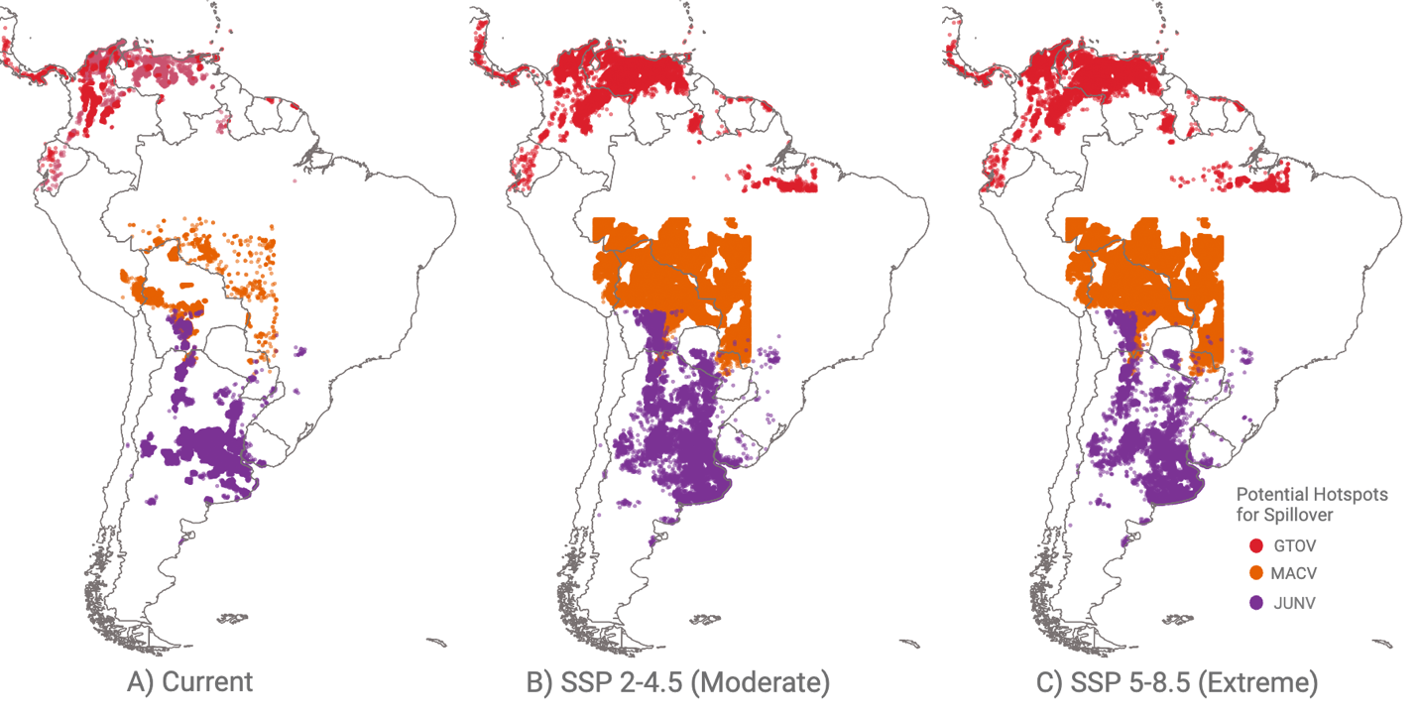

Fig S1.1 Each hotspot represented the top 10% percentile of FOI for successful transmission of NWAs from rodent reservoirs to humans. For each of the NWAs, the hotspots generated were combined for the respective rodent species such that the potential hotspots for GTOV, MACV and JUNV represented the combined risk of spillover into humans from three, one and two rodent reservoirs respectively (see methodology for details). Each species distribution pattern gave rise to different hotspot zones that overall created the potential hotspots for GTOV spillover

In case of GTOV, the number of potential hotspots increased by 1.94X (+ 50,460 hotspots) and 1.96X (+ 51,270 hotspots) for SSP 2-4.5 and 5-8.5 scenarios compared to the current situation (53,290 hotspots). Compared to the current hotspots, for both SSP 2-4.5 and SSP 5-8.5 scenarios of years 2041-2060, more hotspot zones were seen inland for Venezuela, Columbia, Ecuador, Panama, Costa Rica, Guyana, Suriname and Northern part of Brazil, and some of the Caribbean Island nations. The number of hotspots in the coastal regions of these countries also were predicted to increase. Between SSP 2-4.5 and SSP 5-8.5, the predicted number of potential hotspots for SSP 5-8.5 were less but the pattern remained the same.

We predicted very steep rise in the number of potential hotspots of MACV in SSP 2-4.5 (12.8 X; + 54,990 hotspots) and SSP 5-8.5 (11.7X; +50,070 hotspots) compared to the current predicted hotspots (4,664 hotspots). The new as well as persistent hotspots which were concentrated mostly in central Bolivia, southern Peru, northern-most part of Argentina and some parts of western Brazil and Paraguay. Unlike GTOV, the SSP 2-4.5 and SSP 5-8.5 scenarios for years 2041-2060 saw a marked increase and more widespread predicted hotspots in the historically recorded habitat zone of the rodent reservoir in this area. Most of the country of Bolivia and a large portion of bordering western part of Brazil were projected to have numerous potential hotspots in SSP 2-4.5 and SSP 5-8.5. Relatively less marked increase was predicted for eastern Peru, northern Argentina and Paraguay in both the scenarios. In Southern Bolivia, northern Argentina, and Paraguay, we predicted an overlap of potential hotspots for MACV and JUNV (which causes Argentine Hemorrhagic fever in humans) for SSP 5-8.5 scenario. Less overlap was predicted for SSP 2-4.5.

The pattern of hotspots for both scenarios of climate change in the future was inverse compared to the other two viruses for JUNV. For SSP 2-4.5 and SSP 5-8.5, we estimated a reduction in number of hotspots by 0.95X (-6,820 hotspots) and 0.7X (-42,150 hotspots) for SSP 2-4.5 and SSP 5-8.5 respectively compared to current situation (143,080 hotspots). However, the area covered by the potential hotspots was more spread out. Many parts of Argentina, Uruguay, Paraguay and Bolivia were predicted to have new potential hotspots in the future while most of the current hotspots were projected to remain persistent.

Potential hotspots for current, SSP 2-4.5 and SSP 5-8.5 scenarios for each of the six rodent reservoirs individually can be viewed in the following figure (Fig. S1.2).

Figure S1.2 Potential hotspots for zoonotic spillover of New World Arenaviruses (NWAs) in (A) Current, and two future climate scenarios represented by (B) SSP 2-4.5 and (C) SSP 5-8.5 of the Shared Socio-economic Pathways (SSP) scenarios in Coupled Model Intercomparison Project Phase 6 (CMIP6) climate change model. The three NWAs under study were Guanarito virus (GTOV) which causes Venezuelan Hemorrhagic Fever (VHF), Machupo virus (MACV) which causes Bolivian Hemorrhagic Fever (BHF) and Junin virus (JUNV) which causes Argentine Hemorrhagic fever (AHF). Depicted hotspots are estimated based on top 10% percentile of Force of Infection (FOI) estimates for six rodent reservoirs, namely, Zygodontomys brevicauda (short-tailed cane mouse), Sigmodon alstoni (Alston’s cotton rat) which are reservoirs of GTOV, Calomys callosus (large vesper mouse) which is the reservoir of MACV, Calomys musculinus (dryland vesper mouse), Calomys laucha (small vesper mouse) and Oligoryzomys flavescens (yellow Pygmy rice rat) which are the reservoirs of JUNV.

Figure S1.3. Map of predicted new (emerging) and persistent potential hotspots for zoonotic spillover of NWAs based on comparison of current climate to future climate change scenarios, (A) SSP 2-4.5 and (B) SSP 5-8.5. In (A) figure shows in general more potential hotspots for moderate climate change scenario (SSP 2-4.5) compared to (B) Extreme climate change scenario (SSP 5-8.5). Also, (A) has more hotspots that remain persistent from current climate timeframe compared to (B) which shows newer hotspots that do not correspond to the current climate.

Figure S1.4. Maps showing the difference of difference in Force of Infection ($δ_{FOI}^{SSP 2-4.5}-δ_{FOI}^{SSP 5-8.5}$) between SSP 2-4.5 and SSP 5-8.5 climate change scenarios. Grid cells with no difference (rounded to 3 digits after decimal point) are not shown on the map. Top-left: Guanarito virus (GTOV); Bottom-left: Machupo virus (MACV); Right: Junin virus (JUNV).

In terms of potential hotspots for spillover (defined as highest 10%ile FOI estimates), we predicted that the risk of zoonotic transmission for all modeled NWAs increased 5.7 times (~ 700,000 hotspots) in moderate (SSP 2-4.5) and 5.3 times (~ 650,000 hotspots) in extreme (SSP 5-8.5) climate change scenarios, when compared with the current distribution of risk (~ 120,000 hotspots, Supplementary Figure S1.1 and S1.2). The increase in the number of potential hotspots were 7% higher (1.1X) for SSP 2-4.5 compared to SSP 5-8.5.

Section B: Species Distribution Models (SDMs) for rodent reservoirs of zoonotic New World Arenaviruses (NWA)

Table S2.1. Datasets and raster variables used in Species Distribution Models (SDMs)

|  |  |  |  |
| --- | --- | --- | --- |
| **Variable/ Raster name** | **Year range** | **Notes** | |
| **Occurrence data – GBIF** 22 |  |  | |
| *Z. brevicauda* | 1891-2023 | 6142 reported (688 presence-only - unique) | |
| *S.alstoni* | 1911-2017 | 326 reported (62 presence-only - unique) | |
| *C.musculinus* | 1955-2021 | 2287 reported (194 presence-only - unique) | |
| *C.laucha* | 1900-2024 | 2898 reported (137 presence-only - unique) | |
| *O.flavescens* | 1900-2024 | 1136 reported (171 presence-only - unique) | |
| *C.callosus* | 1914-2004 | 2746 reported (165 presence-only - unique) | |
| **Bioclimatic Variables - World Clim Version 2** 23,24 |  | |
| Annual Mean Temperature | 1970-2000 | Bclim 1 | |
| Mean Diurnal Range | 1970-2000 | Bclim 2 | |
| Isothermality | 1970-2000 | Bclim 3 | |
| Temperature Seasonality | 1970-2000 | Bclim 4 | |
| Max Temperature of Warmest Month | 1970-2000 | Bclim 5 | |
| Min Temperature of Coldest Month | 1970-2000 | Bclim 6 | |
| Temperature Annual Range | 1970-2000 | Bclim 7 | |
| Mean Temperature of Wettest Quarter | 1970-2000 | Bclim 8 | |
| Mean Temperature of Driest Quarter | 1970-2000 | Bclim 9 | |
| Mean Temperature of Warmest Quarter | 1970-2000 | Bclim 10 | |
| Mean Temperature of Coldest Quarter | 1970-2000 | Bclim 11 | |
| Annual Precipitation | 1970-2000 | Bclim 12 | |
| Precipitation of Wettest Month | 1970-2000 | Bclim 13 | |
| Precipitation of Driest Month | 1970-2000 | Bclim 14 | |
| Precipitation Seaonality | 1970-2000 | Bclim 15 | |
| Precipitation of Wettest Quarter | 1970-2000 | Bclim 16 | |
| Precipitation of Driest Quarter | 1970-2000 | Bclim 17 | |
| Precipitation of Warmest Quarter | 1970-2000 | Bclim 18 | |
| Precipitation of Coldest Quarter | 1970-2000 | Bclim 19 | |
| **Elevation Data - SRTM v4 (NASA, CGIAR)** |
| Digital Elevation Model (DEM) | 2000 | Elevation in meters | |
| NDVI (MODIS (NASA - USGS) | 2000 | Normalized Difference Vegetation Index for minimum cloud cover | |
| Primary Land (LCLUC (UMA, NASA)) | 1990-2005 | lu_othr | |
| Crop Land (LCLUC (UMA, NASA)) | 1990-2005 | lu_crop | |
| Urban Land (LCLUC (UMA, NASA)) | 1990-2005 | lu_urbn | |
| Secondary Land (LCLUC (UMA, NASA)) | 1990-2005 | lu_secd | |
| Pasture Land (LCLUC (UMA, NASA)) | 1990-2005 | lu_past | |
| Bioclimatic Variables set 1 (World Clim CMIP6 SSP 2-4.5) | 2041-2060 |  | |
| Bioclimatic Variables set 2 (World Clim CMIP6 SSP 5-8.5) | 2041-2060 |  | |
| Land Use 2.45 (LCLUC CMIP6 SSP245) | 2041-2060 |  | |
| Land Use 5.85 (LCLUC CMIP6 SSP585) | 2041-2060 |  | |
| NDVI (MODIS (NASA - USGS)) | 2020-present |  | |
| Digital Elevation Model (DEM) (SRTM v4 (NASA, CGIAR)) | 2000 | Same as current data | |

# 2.1 Current species distribution maps

## Guanarito virus

Guanarito virus which causes Venezuelan Hemorrhagic fever in humans has two identified rodent reservoirs, namely, *Zygodontomys brevicauda* (short-tailed cane mouse) and *Sigmodon alstoni* (Alston’s cotton rat). Short-tailed cane mouse has a natural habitat in North-eastern part of the continent of South America (countries of Venezuela, Columbia, Guyana, Suriname, Northern part of Brazil and French Guiana) 25. It can inhabit a varied set of environments ranging from forested and dense grass areas to open agricultural lands but prefers sites close to water bodies. Adults weigh up to 60-80 grams with no sexual dimorphism and a litter size of 5-11 pups. These mice can survive from 1-5 years although detailed information on this is unavailable. Alston’s cotton rat is found naturally in the North-eastern part of the continent of South America (countries of Venezuela, Columbia, Suriname, Guyana, Brazil and French Guiana) 25. Its natural habitat is like other sigmodontid rodents that includes flatlands with shrubs, grass and open crop fields on low elevation lands. Most activity of the rats can be observed during daytime (diurnal). Unconfirmed reports of litter size include 3-7 pups.

Using historical occurrence data from GBIF for both rodent reservoirs of Guanarito virus, we converted the presence-only data to presence-absence data that was combined with the environmental and ecological raster data from various sources (see main text) to create species distribution maps. The SDM maps for current distribution can be seen in Figure S2.1 (a) and Figure S2.1 (b).

1. ***Z.brevicauda***

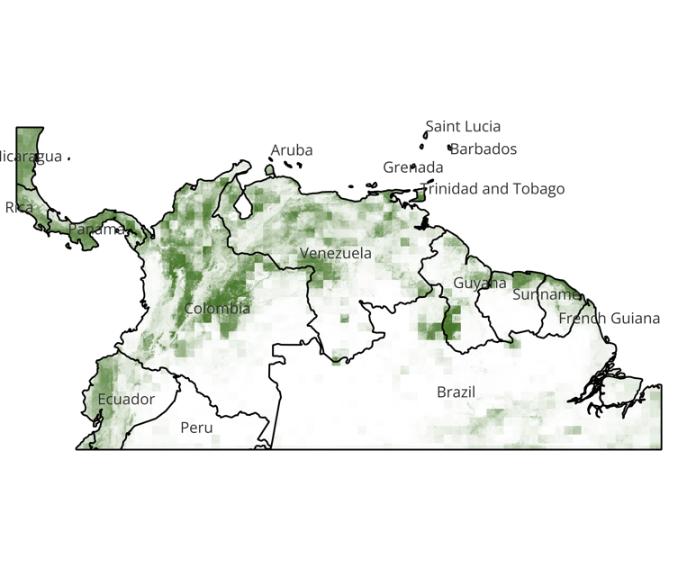

1. ***S.alstoni***

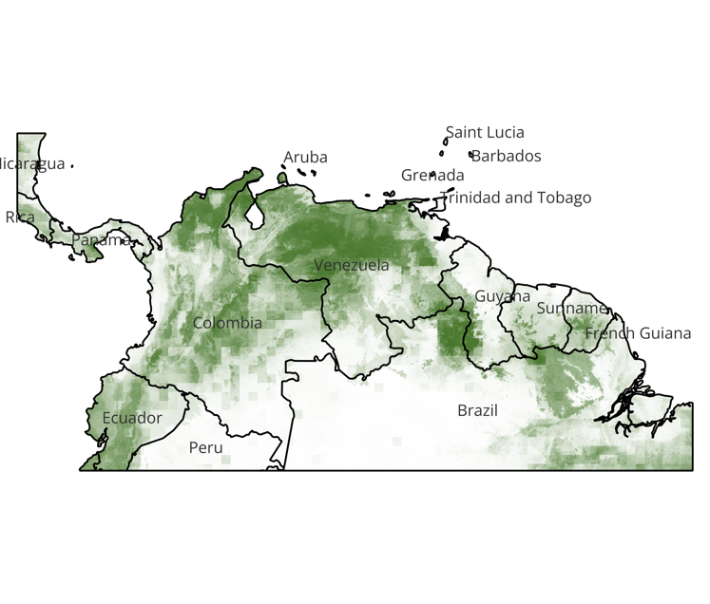

Figure S2.1. Current species distribution maps (from combination of outcomes from all four ensemble algorithms) for the two rodent reservoirs of Guanarito virus showing probabilities of presence (from 0 to 1).

### Z.brevicauda

Higher probabilities of presence were seen around the national parks in Columbia, Venezuela, Panama, Ecuador, Guyana and Suriname (Fig S2.1 a). The probabilities of presence were lower than threshold (p < 50%) near big metropolitan cities like Bogota, Medellin, Caracas, Georgetown, Quito in the corresponding countries. Only in Paramaribo and Panama City, the largest cities in Suriname and Panama respectively, higher probabilities of presence were estimated. This showed that the mouse species is generally present in forested and bordering grassland as well as cropped rural/ semi-urban areas. In general, the distribution patterns were most sensitive to seasonality and fluctuations in temperature, and cropland as well as other land use variables (Table S2.1).

### S.alstoni

The higher probabilities of presence for this species also somewhat coincided with the other rodent, *Z.brevicauda* near the central areas of Venezuela, center-east of Columbia, Boa vista border between Venezuela and northern Brazil, near all the national forests (Figure S2.1 b). However, the key difference was that higher probabilities were estimated for zones in and around the cities of Cartagena, Bogota in Columbia, Caracas, Maracaibo, Valencia in Venezuela which are some of the largest metropolitan areas. Whereas Georgetown in Guyana, Paramaribo in Suriname, Panama City in Panama displayed less than threshold presence probabilities. In general, the SDMs showed that the species presence is significantly higher in populated peri-urban and urban areas especially those with flatlands and presence of cropped or grassed areas surrounding cities. Like, *Z.brevicauda*, *S.alstoni* is also expected to be present near dense forested areas in the national or state park areas. In general, the species distribution was most sensitive to precipitation and temperature seasonality, especially during the dry season (Table S2.1).

## Machupo Virus

Machupo virus which causes Bolivian hemorrhagic fever in humans when spillover occurs, has one identified rodent reservoir species, namely, *Calomys callosus* (large vesper mouse). Large vesper mouse is a nocturnal mice species that is generalist in its habitat and has a wide distribution. Found primarily in Bolivia, it has also been reported in Argentina, Paraguay, and Brazil 25. Due to their generalist habitation patterns, they can inhabit a variety of ecological niches. Litter sizes range between 3-5 pups and the adults who weigh between 30-50 grams, do not show sexual dimorphism. The SDM maps for current distribution of large vesper mouse can be seen in Figure S2.1 c.

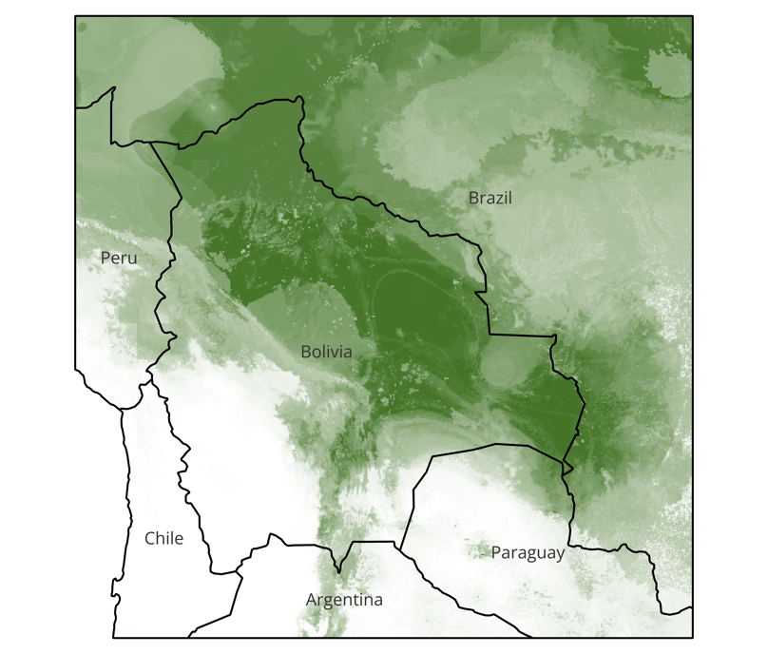

Figure S2.1(c). Current species distribution maps for the rodent reservoirs of Machupo virus showing probabilities of presence (from 0 to 1); combined outcomes from all four ensemble algorithms.

### Calomys callosus

Current SDMs of large vesper mouse show high probabilities of presence in the plains of Bolivia bordering the countries of Brazil, Argentina and Paraguay (Figure S2.1 c). Except for the Bolivian Andes regions, all regions show higher probabilities of presence than the threshold of 50%. The mouse species can be estimated to inhabit large diverse areas irrespective of rural or urban human settlements. The species presence, in general, was sensitive to features such as ranges of annual temperature and duration of day as well as total annual precipitation (Table S2.1).

## Junin Virus

Junin virus which causes Argentinian hemorrhagic fever in humans has three identified rodent reservoir species, namely, Calomys *musculinus* (Dryland Vesper Mouse), *Calomys laucha* (Small Vesper mouse) and *Oligoryzomys flavescens* (Yellow Pygmy Rice Rat).

Dryland Vesper mouse is historically found in Argentina, Bolivia, and Paraguay where it occupies a wide variety of habitats, like natural grasslands, shrub steppes, crop field borders, and human-disturbed environments such as wastelands, railroads, and urban garbage dumps 26. As the common name suggests, its abundance changes seasonally, driven by natural climatic variations and land-use practices that affect resource availability.

*Calomys laucha* or Small Vesper mouse is historically found in the Chaco plains of Argentina, Bolivia, Paraguay, southeastern Brazil, small parts of Uruguay and Chile. Adults weigh approximately 13 grams. The mice prefer dryer, flat plains with crops or grass covered areas and where soil is sandy that helps them create burrows. Litter size can range from 5 to 10 pups per litter, and they follow a monogamous mating and nesting system. Key ecological characteristics include seasonal changes to habitat selection where high vegetation areas are preferred in summer and winters are marked by more peri-domestic and open habitats.

Yellow pygmy rice rat is commonly found in Southern Brazil, Uruguay, Northern Argentina. These rats can inhabit arboreal; terrestrial be semi-aquatic areas and are typically spotted in pasture or croplands 25. These rats are nocturnal in nature and do not move outside of natural home range. Very little is known about their reproductive behavior and unconfirmed reports include a litter size of 3-7 pups and seasonality in reproductive behavior. Adults can weigh around 40 grams.

The SDM maps for current distribution of the three rodent reservoirs for Junin virus can be seen in Figure S2.2.

1. **Calomys musculinus**

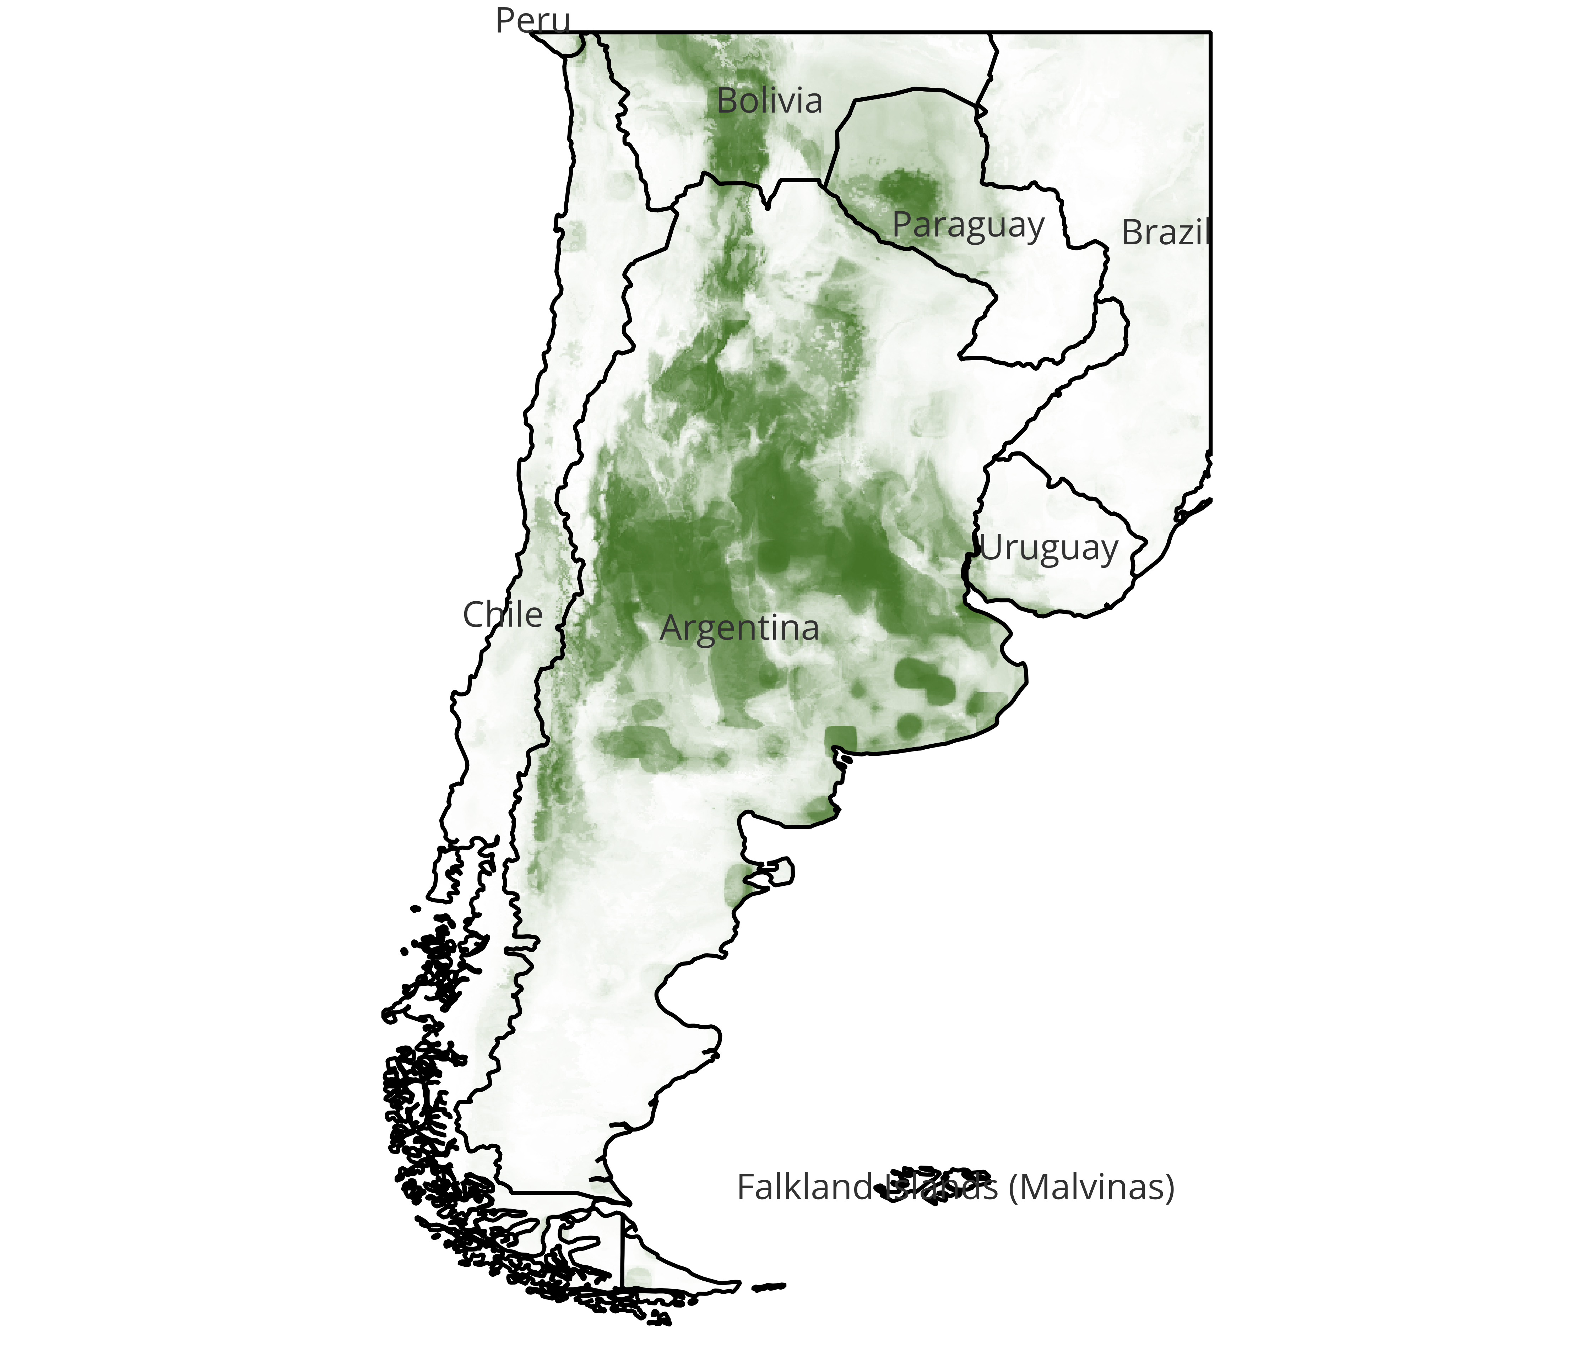

1. **Calomys laucha**

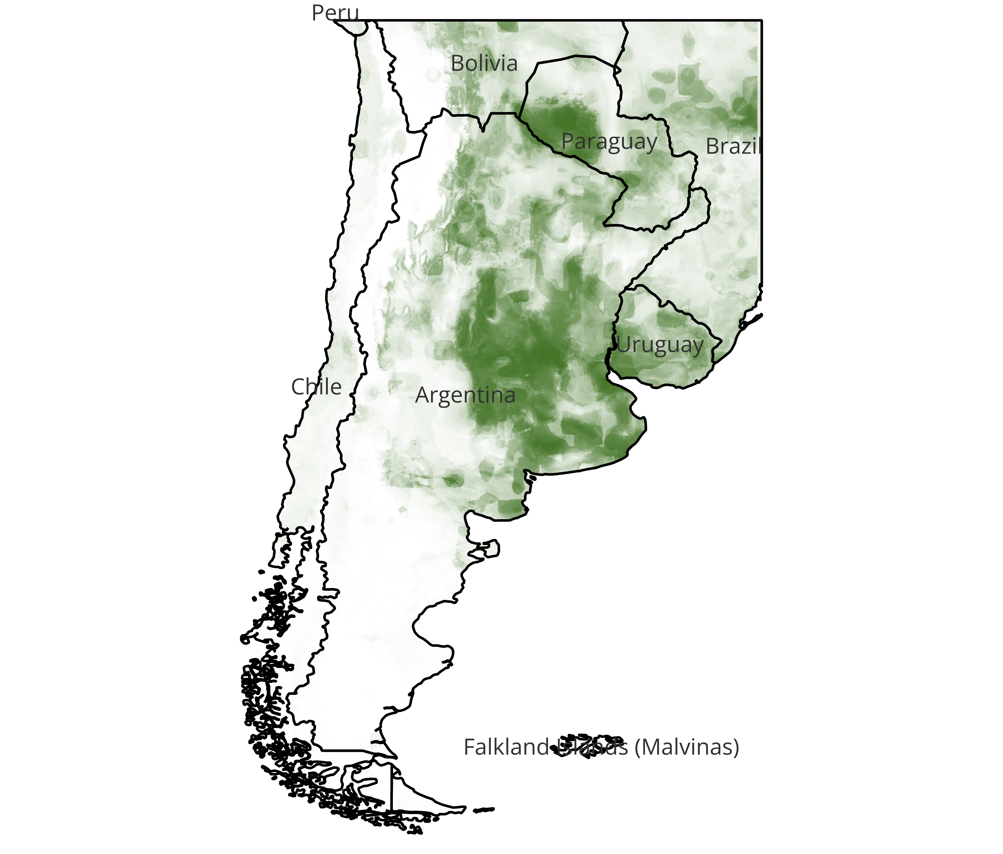

1. **Oligoryzomys flavescens**

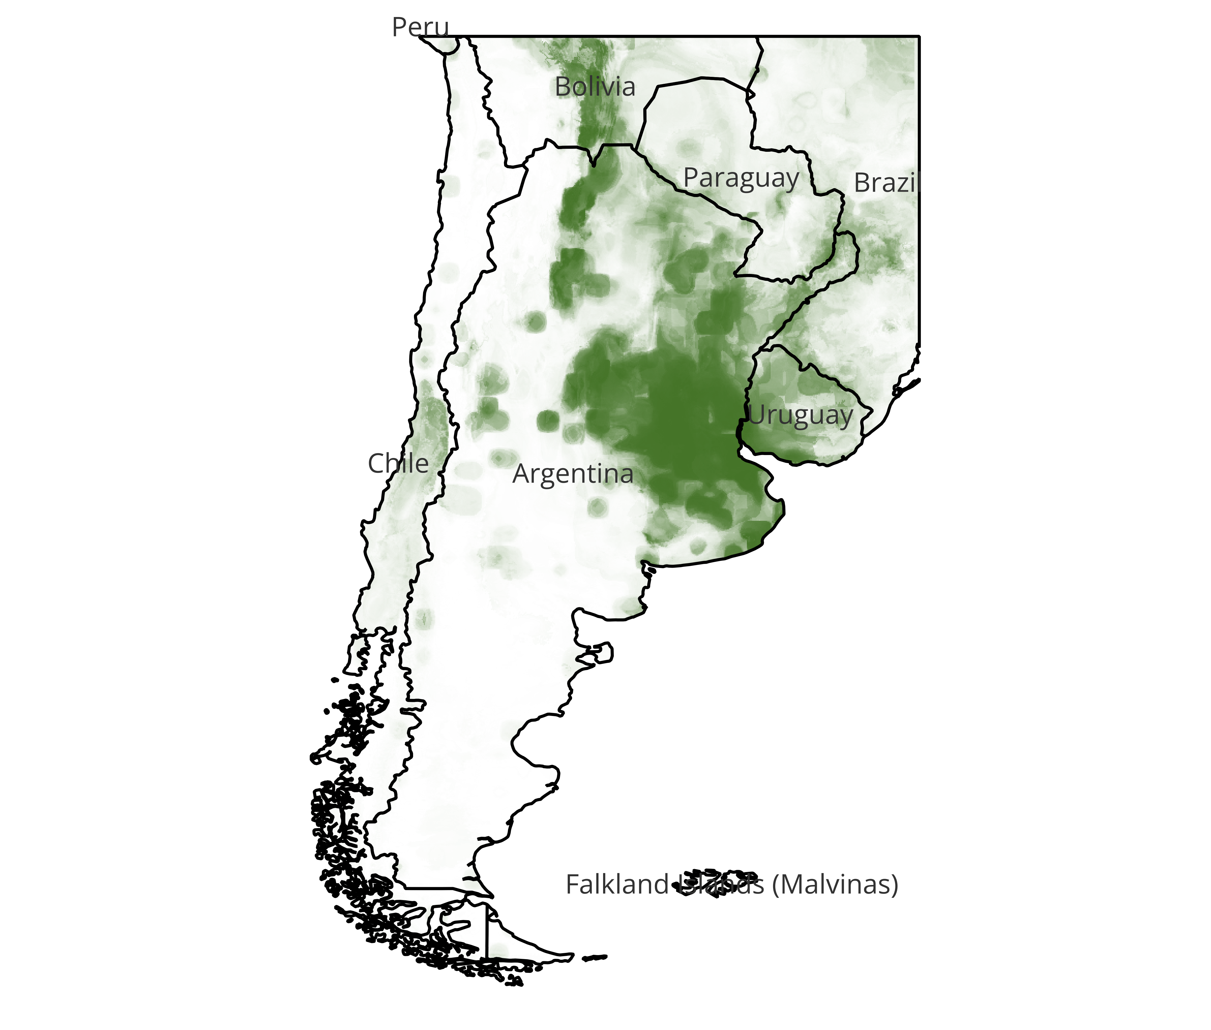

Figure S2.2. Current species distribution maps for the three rodent reservoirs of Junín virus showing probabilities of presence (from 0 to 1); combined outcomes from all four ensemble algorithms.

### Calomys musculinus

As seen in Figure S2.2 (a), higher probabilities of presence were estimated in the regions such as Pampas, Espinal, Monte de Llanuras y Mesetas, Chaco seco, Monte de Sierras y Bolsones, and Yungas which are situated in the basins of central Argentina. For details, see our other work 26. The species distribution was mostly influenced by presence of urban land and total annual precipitation among other eco-environmental features (Table S2.2).

### Calomys laucha

The species distribution patterns were estimated much like those of C.musculinus (Figure S2.2 (a, b)). The key differences were that lower probabilities than threshold of 50% were estimated in the Andean mountainous region bordering Chile and Argentina. Also, much higher probabilities were observed around metropolitan cities on coast of Argentina including Buenos Aires. The species distribution was most sensitive to features such as cropland and maximum recorded temperature in the warmest month, in other words the intensity of summer was a key feature for species distribution in general (Table S2.2).

### Oligoryzomys flavescens

Compared to the other two reservoirs, the pygmy rat distribution patterns were slightly different in estimation. Highest probabilities were estimated in Cordoba, Entre Rios and Buenos Aires provinces in Argentina and coastal areas of Uruguay which surround the Rio de la Plata region at the confluence of Uruguay river and Parana river in the Pampa ecoregion (Figure S2.2 (c)).The species distribution was sensitive to features such as presence of crop or urban lands, total annual precipitation and precipitation during the warm period in general (Table S2.2).

# 2.2 Important features for current species distribution maps

The variability in the species distribution patterns of all the rodent reservoirs of the three NWAs under study were marked by variability in the importances of eco-environmental features that were used to predict the species distribution maps. Table S2.2 shows the top 5 most important features per the algorithm for all six of the rodent reservoirs of the three NWAs.

Table S2.2. Topmost important features for rodent reservoir species distribution models.

|  |  |  |  |
| --- | --- | --- | --- |
| Species | Algorithm | Top 5 selected (number of times selected in 100 simulations with Recursive Feature Elimination) | Top 5 feature importances (feature importance in mean reduction of impurity – 2 decimal points) |
| *Z.brevicauda* | RF | * DEM (92) * LUCrop (100) * LUOthr (100) * LUpast (100) * LUurbn (100) | * LUothr (0.13) * LUurbn (0.12) * LUcrop (0.12) * LUpast (0.09) * LUsecd (0.06) |
|  | ET | * Mean Diurnal Range (99) * LUother (100) * LUcrop (100) * LUpast (100) * LUsecd (100) | * LUothr (0.16) * LUcrop (0.11) * LUpast (0.1) * Precipitation Seasonality (0.06) |
|  | XGB | * Isothermality (94) * LUSecd (95) * LUurbn (95) * LUcrop (100) * LUothr (100) | * LUothr (0.18) * LUcrop (0.17) * LUurbn (0.07) * LUpast (0.06) * Isothermality (0.06) |
|  | LGBM | * Temperature Seasonality (93) * Isothermality (94) * NDVI (96) * LUcrop (97) * Precipitation Seasonality (98) | * Isothermality (0.08) * Temperature Seasonality (0.08) * NDVI (0.07) * LUcrop (0.07) * Mean Diurnal Range (0.07) |
| *S.alstoni* | RF | * Precipitation Seasonality (91) * Precipitation of Driest Month (93) * LUpast (97) * Temperature Seasonality (98) * Precipitation of Driest Quarter (100) | * Precipitation of Driest Quarter (0.1) * Temperature Seasonality (0.09) * Precipitation of Driest Month (0.08) * LUpast (0.08) * Precipitation Seasonality (0.08) |
|  | ET | * Temperature Seasonality (97) * LUpast (97) * Precipitation Seasonality (97) * Precipitation of Driest Month (98) * Precipitation of Driest Quarter (100) | * Precipitation Seasonality (0.08) * Precipitation of Driest Quarter (0.08) * LUpast (0.08) * Precipitation of Driest Month (0.08) * Temperature Seasonality (0.08) |
|  | XGB | * LUpast (78) * Isothermality (79) * LUurbn (86) * Precipitation of Driest Quarter (93) * Temperature Seasonality (97) | * Precipitation of Driest Quarter (0.16) * Temperature Seasonality (0.08) * Precipitation of Warmest Quarter (0.07) * LUpast (0.07) * LUurbn (0.07) |
|  | LGBM | * Precipitation of Wettest Month (81) * Precipitation of Warmest Quarter (81) * Mean Diurnal Range (82) * Temperature Seasonality (88) * LUurbn (96) | * NDVI (0.09) * LUurbn (0.09) * Temperature Seasonality (0.08) * Precipitation of Wettest Month (0.08) * Precipitation of Driest Quarter (0.07) |
| *C.callosus* | RF | * Annual Precipitation (96) * Mean Diurnal Range (99) * Precipitation of Wettest Month (100) * Precipitation of Wettest Quarter (100) * Temperature annual Range (100) | * Mean Diurnal Range (0.12) * Precipitation of Wettest Month (0.09) * Temperature Annual Range (0.09) * Precipitation of Wettest Quarter (0.08) * Min Temperature of Coldest Month (0.08) |
|  | ET | * Annual Precipitation (96) * Precipitation of Wettest Quarter (98) * Precipitation of Wettest Month (99) * Mean Diurnal Range (99) * Temperature Annual Range (100) | * Temperature Annual Range (0.11) * Mean Diurnal Range (0.09) * Precipitation of Wettest Month (0.07) * Annual Precipitation (0.07) * NDVI (0.07) |
|  | XGB | * Temperature Seasonality (81) * Precipitation of Wettest Quarter (82) * Mean Diurnal Range (86) * Precipitation of Wettest Month (87) * Temperature Annual Range (95) | * Mean Diurnal Range (0.2) * Precipitation of Wettest Quarter (0.11) * Precipitation of Wettest Month (0.09) * Temperature Annual Range (0.08) * Annual Mean Temperature (0.07) |
|  | LGBM | * Isothermality (88) * Mean Diurnal Range (89) * NDVI (93) * Temperature Seasonality (93) * Temperature Annual Range (96) | * NDVI (0.1) * Temperature Annual Range (0.08) * Temperature Seasonality (0.08) * Isothermality (0.08) * Annual Precipitation (0.07) |
| *C.musculinus* | RF | * Mean Temperature of Wettest Quarter (92) * Temperature Annual Range (95) * Annual Precipitation (100) * LUurbn (100) * Mean Diurnal Range (100) | * LUurbn (0.11) * Mean Diurnal Range (0.09) * Annual Precipitation (0.08) * Precipitation of Wettest Quarter (0.07) * Temperature Annual Range (0.07) |
|  | ET | * Temperature Annual Range (93) * LUpast (94) * Mean Diurnal Range (96) * Mean Temperature of Wettest Quarter (97) * Annual Precipitation (98) | * Mean Diurnal Range (0.07) * LUpast (0.07) * Annual Precipitation (0.07) * Mean Temperature of Wettest Quarter (0.07) * Temperature Annual Range (0.07) |
|  | XGB | * LUpast (82) * Precipitation Seasonality (85) * Mean Diurnal Range (96) * Annual Precipitation (97) * LUurbn (99) | * Annual Precipitation (0.11) * LUurbn (0.1) * Mean Diurnal Range (0.09) * Temperature Annual Range (0.08) * Precipitation Seasonality (0.07) |
|  | LGBM | * Max Temperature of Warmest Month (87) * LUpast (92) * Mean Diurnal Range (96) * LUSecd (96) * LUurbn (100) | * LUurbn (0.11) * Mean Diurnal Range (0.1) * LUsecd (0.08) * LUpast (0.08) * Max Temperature of Warmest Month (0.07) |
| *C.laucha* | RF | * Max Temperature of Warmest Month (89) * Annual Precipitation (90) * Mean Temperature of Wettest Quarter (95) * Temperature Annual Range (98) * LUcrop (100) | * LUcrop (0.12) * Temperature Annual Range (0.08) * Mean Temperature of Wettest Quarter (0.07) * Max Temperature of Warmest Month (0.07) * Annual Precipitation (0.07) |
|  | ET | * Max Temperature of Warmest Month (92) * Annual Precipitation (93) * Temperature Annual Range (94) * Mean Temperature of Wettest Quarter (99) * LUcrop (100) | * LUcrop (0.1) * Mean Temperature of Wettest Quarter (0.08) * Temperature Annual Range (0.07) * Max Temperature of Warmest Month (0.07) * Mean Temperature of Warmest Quarter (0.07) |
|  | XGB | * Temperature Annual Range (82) * Max Temperature of Warmest Month (82) * LUurbn (89) * Annual Precipitation (92) * LUcrop (100) | * LUcrop (0.15) * Annual Precipitation (0.08) * LUothr (0.08) * Precipitation of Coldest Quarter (0.07) * LUpast (0.07) |
|  | LGBM | * LUsecd (86) * LUcrop (89) * LUothr (90) * LUpast (91) * LUurbn (99) | * LUurbn (0.12) * LUcrop (0.08) * LUsecd (0.08) * Lupast (0.08) * Luothr (0.08) |
| *O.flavescens* | RF | * Mean Temperature of Wettest Quarter (88) * Precipitation of Warmest Quarter (98) * Annual Precipitation (98) * LUurbn (100) * LUcrop (100) | * LUurbn (0.16) * LUcrop (0.09) * Precipitation of Warmest Quarter (0.07) * Precipitation in wettest Month (0.07) * Annual Precipitation (0.07) |
|  | ET | * Precipitation of Warmest Quarter (93) * Annual Precipitation (94) * LUurbn (96) * Mean Temperature of Wettest Quarter (98) * LUcrop (100) | * LUcrop (0.09) * Mean Temperature of Wettest Quarter (0.08) * Annual Precipitation (0.08) * Precipitation of Warmest Quarter (0.07) * Mean Temperature of Coldest Quarter (0.07) |
|  | XGB | * LUcrop (87) * Max Temperature of Warmest Month (87) * Annual Precipitation (92) * Precipitation of Warmest Quarter (92) * LUurbn (100) | * LUurbn (0.2) * Annual Precipitation (0.1) * Precipitation of Warmest Quarter (0.09) * Precipitation of Wettest Month (0.08) * Precipitation of Coldest Quarter (0.05) |
|  | LGBM | * Annual Precipitation (88) * Max Temperature of Warmest Month (90) * LUsecd (91) * LUcrop (94) * LUurbn (100) | * LUurbn (0.13) * LUcrop (0.08) * Max Temperature of Warmest Month (0.08) * LUsecd (0.07) * Annual Precipitation (0.07) |

Note: Abbreviations: RF: random forest algorithm, ET: Extra Trees algorithm, XGB: eXtra Gradient Boost, LGBM: Light Gradient Boost Model, LUcrop: Land use – cropland, LUurban: Land use – urban land, LUpast: Land use – Pasture land, LUsecd: Land use – secondary/ non-agricultural land, LUothr: Land use – Other/ Forested land use, NDVI: Normalized Difference Vegetation Index.

In contrast to Table S2.2, the Figure S2.2 shows the feature importance of all the 26 eco-environmental features for all six rodent reservoirs distributed over the 4 algorithms of 3 NWAs.

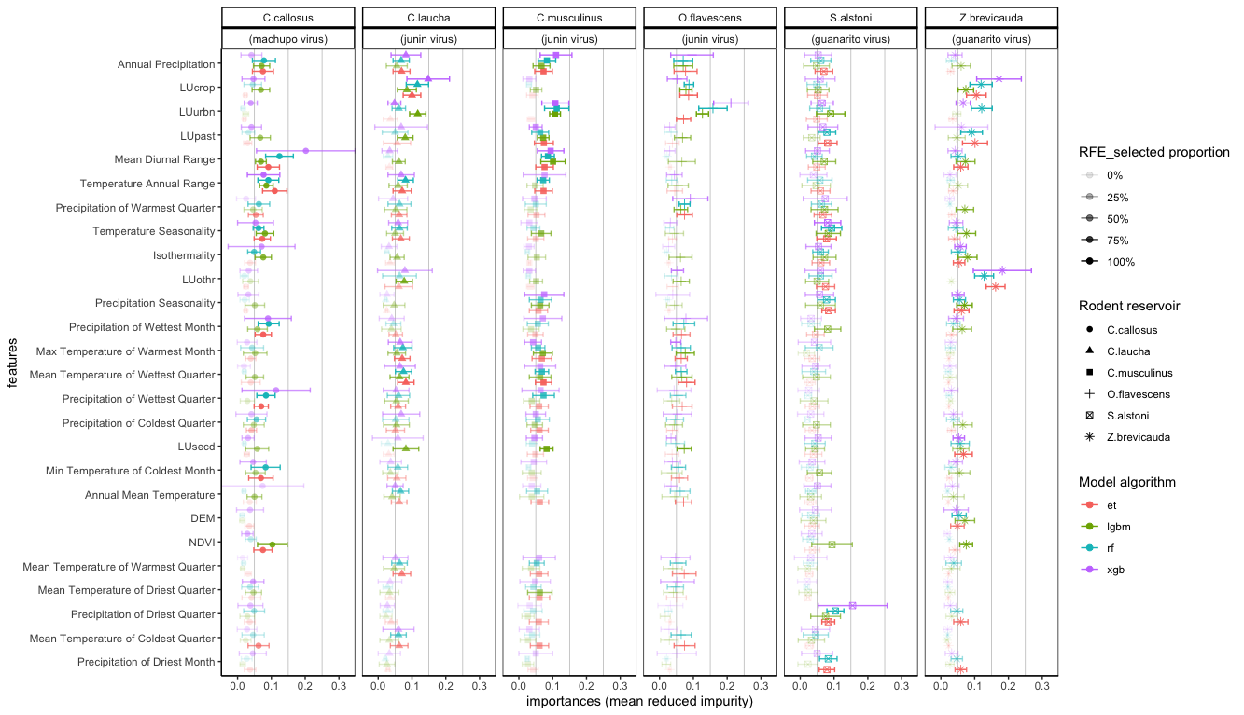

Figure S2.2. Feature importances of all 26 raster features based on mean reduced impurity from the four ensemble algorithms along classified based on number of times the feature was selected in Recursive Feature Elimination (RFE) technique.

# 2.3 Model performance metrics

Depending on the variability in the eco-environmental raster features, the four modeling algorithms, namely, Random Forest (RF), Extra Trees (ET), Extra Gradient Boost (XGB) and Light Gradient Boosting Model (LGBM) performed adequately. In general, the 5-fold cross validation accuracy ranged between 77% and 87%, the Area Under the ROC Curve (AUC-ROC) was between 83% and 95% and the recall for positive responses (presence of species in the given geographical context) was between 80% and 87%. Similarly, the F1 scores on the test data which was 25% of the original data (75% being the training and validation set) was 77-88% with a 12-20% false response rate.

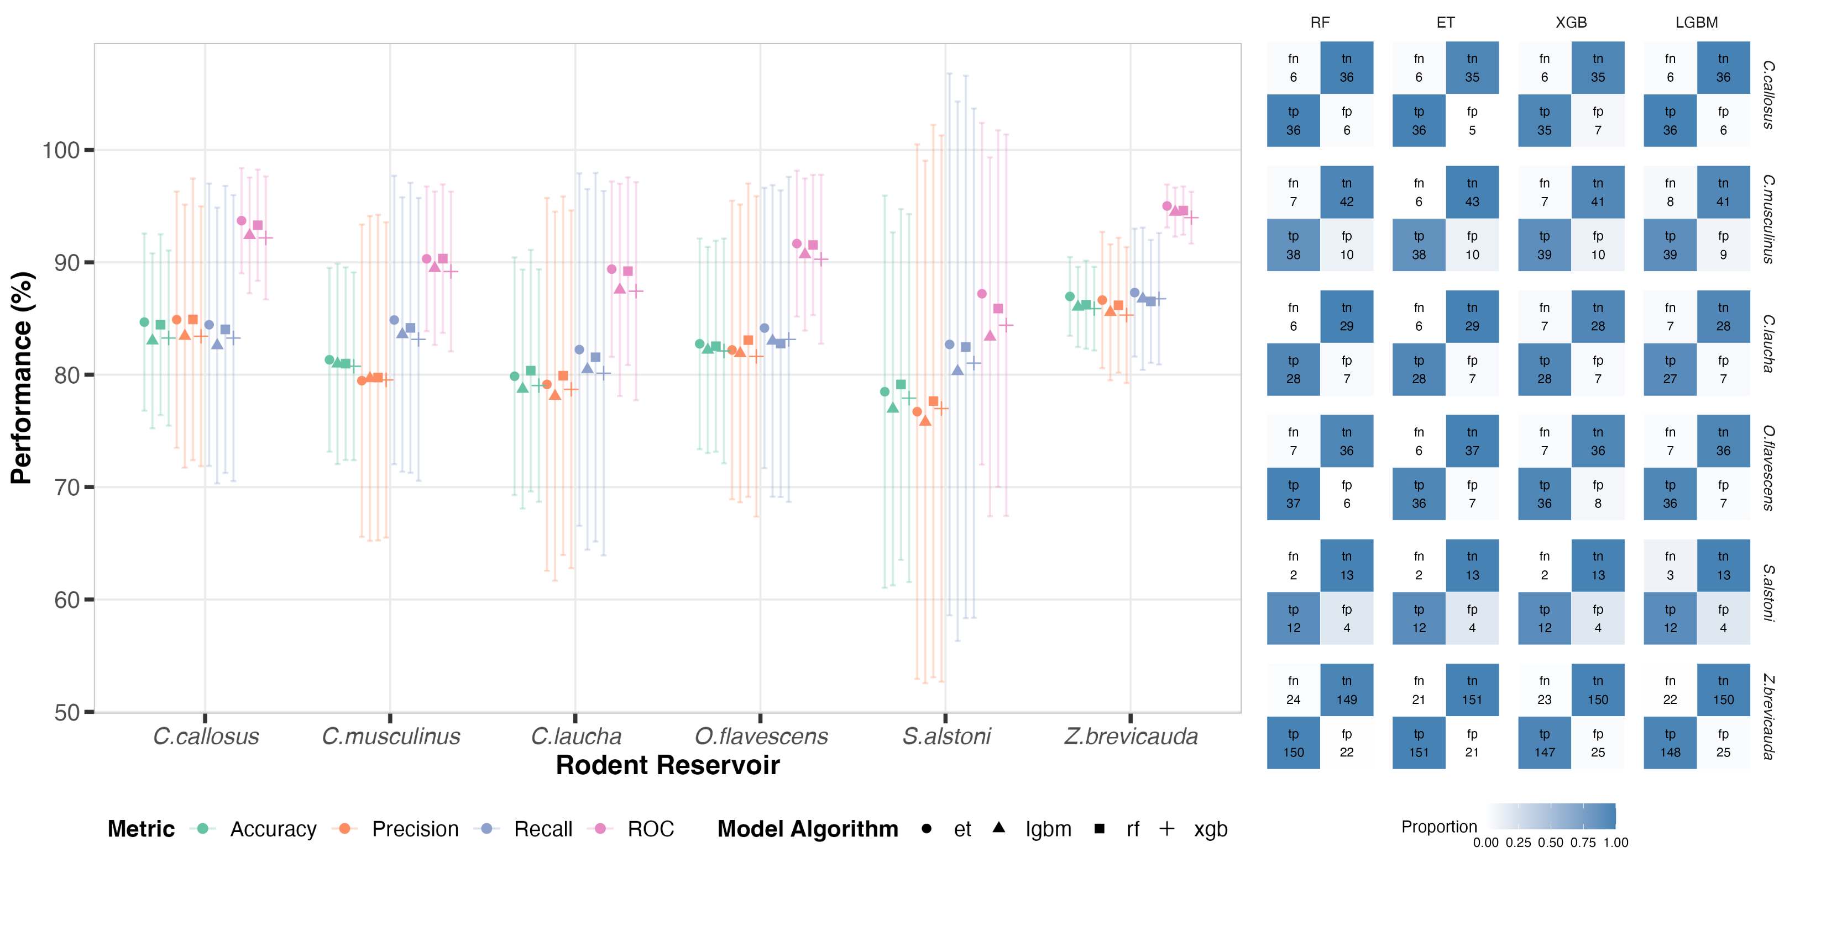

Figure S2.3. Confusion matrices for SDM model predictions over four algorithms for all six species of rodent reservoirs of NWAs (Abbrev; fn = false negatives, tp = true positives, fp = false positives, tn = true negatives)

# 2.4 Projected Future species distribution maps

Using CMIP6 models of climate change scenarios, we projected the distribution of the rodent reservoirs of Guanarito virus, Machupo virus and Junin virus in years 2041 to 2060. We selected two contrasting scenarios of SSP 2-4.5 or moderate climate change scenario and SSP 5-8.5 or extreme climate change scenario for this SDM projection. Using the same trained models of current SDMs, we imputed the probabilities for presence of the species in all the geographical locations in the current expanse of habitation for the rodent species as observed in the GBIF occurrence data.

In general, the projected SDMs had remarkably different probabilities of presence for the rodent species predicting a radical change in the habitat of the rodent reservoirs to be expected in the future. However, the differences in the probabilities of presence between the two CMIP6 scenarios, namely SSP 2-4.5 and SSP 5-8.5, were more subtle and hard to identify. Differences in probabilities of presence and distribution patterns of all six rodent reservoir species for NWAs is summarized in Table S2.3.

Table S2.3. Summary of delta maps (difference in probabilities of presence) for SSP 2-4.5 and SSP 5-8.5 compared to current species distribution maps (see Figure S2.3).

|  |  |  |  |  |
| --- | --- | --- | --- | --- |
| **Virus** | **Species** | **CMIP6 Scenario** | **Increase in Probabilities** | **Decrease in Probabilities** |
| **Guanarito Virus** | *Z.brevicauda* | SSP 2-4.5 | Around rivers: Orinoco (Columbia), Branco (near Boa Vista), Amazon & tributaries (Xingu) in Brazil | Columbian Andes (north and south of Medellin)  River Sipapo  River Orinoco (Venezuela)  Marahuaca National Park  Venezuela-Brazil border (Neblina National Park) |
|  |  | SSP 5-8.5 | Higher intensity around rivers Branco, Amazon (Boa Vista, Manaus, Santarem, Tucurui)  River Meta (Columbia), River Apure (Venezuela) | National Park Cnaruco-Capanoparo  River Sipapo  South of Las Vegas (Venezuela)  Venezuela-Brazil border (Neblina National Park) |
|  | *S.alstoni* | SSP 2-4.5 | East & west of Guri Reservoir (San Pedro Forest, La Paragua)  River Cano Manamo (up to Gulf of Paria)  River Meta (Columbia-Venezuela border)  River Magdalena (north Columbia)  Northern border of Brazil (Guyana, Serra do Sol, Roraima)  South of Amazon Delta (Itacotiara to Mapaca) | Venezuela-Brazil border (Canaima National Park, Santa Inez)  River Caguan & tributaries (south-west Columbia)  Monkey Mountain & Karisparu (Guyana)  Central Suriname, French Guiana  Northern Brazil (Suriname & French Guiana border) |
|  |  | SSP 5-8.5 | Similar to SSP 2-4.5 with more intensity | Similar to SSP 2-4.5 with more intensity |
| **Machupo Virus** | *C.callosus* | SSP 2-4.5 | West of Paraguay River (Gran Chaco basin, north of Concepcion)  River Pilcomayo (Bolivia-Argentina border)  Campo Grande (Brazil)  South of Salinas and Aguada Blanca (Peru) | West of Filadelfia (Paraguay)  Kaa Iya National Park (north Paraguay-Bolivia border)  West of River Bermejo (Argentina-Bolivia border) |
|  |  | SSP 5-8.5 | Tacna (Peru-Chile border)  East of River Cuiaba (Brazil) | Similar to SSP 2-4.5 |
| **Junin Virus** | *C.musculinus* | SSP 2-4.5 |  | <need to compare it with Nuri’s work> |
|  |  | SSP 5-8.5 | <need to compare it with Nuri’s work> | <need to compare it with Nuri’s work> |
|  | *C.laucha* | SSP 2-4.5 | Gran Chaco plains (east of Andes in Argentina)  Paraguay (northern border with Brazil)  Rio Negro Province (Argentina)  Southern Bolivia-Argentina border (River Picomayo, Villa Montes, Camiri)  Maringa (Brazil)  Mato Grosso do Sul (Brazil) | Around Santa Cruz de la Sierra  Cordoba plains (Argentina)  around city of Junin  Mar del Plata (Atlantic coast)  Pampas (Argentina)  around Buenos Aires metropolis  Argentina-Uruguay border (Uruguay river)  Eastern Uruguay (Treinta y Tres) |
|  |  | SSP 5-8.5 | Similar to SSP 2-4.5 | Similar to SSP 2-4.5 but more intensity around Inao National Park (Bolivia)  Tri-border area (Bolivia, Argentina, Paraguay) |
|  | *O.flavescens* | SSP 2-4.5 | Sporadic pockets in central plains (Cordoba, southern Buenos Aires)  Bolivian Andes (near Oruro) | Eastern Argentina (borders with Paraguay, Brazil, Uruguay)  East of Andes (Vallegrande to Villa Montes) |
|  |  | SSP 5-8.5 | More pronounced in Central Chile (Talca to Temuco) | Borders (Paraguay, Brazil, Argentina near Cuidad del Este) |

Section C: Modeling choices and assumptions

# 3.1 CMIP6 models and SSP scenarios

The outcomes of this study assumed the validity of the climate change scenarios that were drawn from the SSP scenarios of the CMIP6 models. CMIP6 provided substantial granularity in resolution and more nuances in the prediction of climate change over CMIP5 27. The SSP 2-4.5 (Moderate Climate Change Scenario) and SSP 5-8.5 (Extreme Climate Change Scenario) are amongst the most well researched scenarios with counterparts in previous CMIP5 model 28. It must be noted that neither of the scenarios meet the global climate agreement goals. Considering this, we believe that our outcomes should be viewed with the context of slow (SSP2.45) or no (SSP 5-8.5) progress towards sustainable climate goals. Based on unfolding geopolitical diplomacy surrounding climate change, these models can be extended to other scenarios featured in the CMIP6 suite.

# 3.2 Biodiversity of rodent reservoirs

In our study, we modeled the rodent reservoirs such as *Zygodontomys brevicauda* and *Sigmodon alstoni* for GTOV, *Calomys callosus* for MACV and *Calomys musculinus, Calomys laucha* and *Oligoryzomys flavescens* for JUNV. GTOV seroprevalence was reported and confirmed in *Z.brevicauda* and *S.alstoni* by multiple sources 29–31. Tesh et al. also reported *Oligoryzomys fulverscens* and *Rattus rattus* as potential reservoirs for GTOV but subsequent literature did not confirm this 29,30. Reservoir status of *C. musculinus, O. flavescens* and *C. laucha* for JUNV was repeatedly reported 32–34. *C.callosus* was implicated as the rodent reservoir for both Machupo (MACV) and Chapare virus (CHAV) in Bolivia 32,35 and was recently confirmed as the reservoir for MACV 36.

Despite basing the selection of species to focus on based on previous accounts, there is significant ambiguity in exact number of species that were implicated as rodent reservoirs for NWAs 37,38. Most NWAs have cospeciation and shared evolutionary history with the rodent reservoirs thereby being adaptable to the rodent species 39. Also, presence of multiple species of NWA reservoirs in same geographical coordinates can indicate increased risk of transmission as well as bigger outbreak (controlling for human activities) 40–43. Overlap of high human movement such as those of migrant farm labor and high diversity of rodent reservoir habitats would then constitute higher zoonotic risk 44.

# 3.3 Use of FOI-SDM framework

The FOI calculations used in this study to attribute risk profiles for spillover into human populations are based on assumption of density-dependent interaction and consequently, transmission of arenaviruses from the rodent populations to human population. There are several implicit assumptions in this calculation. Firstly, we assumed the transmission rate parameter of rodent populations based on the available literature pertaining to Lassa Fever Virus which is an Old-World Arenavirus (OWA). It is reasonable to expect that the NWA and OWA transmission to humans might not be comparable. However, we made this choice due to lack of transmission studies on NWA transmission to humans. Also, due to density-dependence, we assumed that the force of infection will asymptotically increase with the transmission rate parameter until a state of equilibrium is achieved. Secondly, the rodent populations were estimated based on their presence probabilities predicted from SDM outcomes. Depending on which species is being modeled, the occurrences predicted from SDMs provide poor alternative to estimating population densities without input of validated data on species abundance while developing SDMs 45,46.

Given that the historical occurrence data from GBIF 47 was not informative in the standard population size of NWA rodent reservoirs, we estimated the rodent populations based on their predicted presence probabilities. Our estimation was approximately similar to the predicted litter size and family unit of rodent species by Han et al.40 which is to date the only available literature on the group traits of New World rodents 48. We theorize that this framework can be used for identifying areas for field work to generate transmission and outbreak data for neglected yet emerging diseases such as those caused by NWAs, that can validate the usefulness of these models.

# 3.4 Sampling bias in the data

We used presence-only occurrence data for rodent reservoir SDMs in this study that can introduce geographical sampling bias when generating naïve pseudoabsences 49,50. Further, for machine learning approaches such as those in this study, the prediction accuracy is highly sensitive to the method in which pseudoabsences are generated 51. To reduce this bias, we used the uniform approach of generating context-dependent pseudoabsences designed by Da Re et al. (2023) 49. Numerous other approaches to generate ecologically consistent pseudoabsences have been used elsewhere in the literature. For example, EcoPA by Broussin et al. (2024) and three-step clustering approach by Senay et al. (2013) are viable alternatives 52,53.

Further, most NWAs outbreaks occur in rural areas within agrarian worker communities and when they occur, the patients exhibit non-specific symptoms of hemorrhagic fever that make rapid differential diagnosis difficult without molecular and genomic testing. A recent singular case of Chapare virus was reported by the International Health Regulations (IHR) National Focal Point (NFP) for the Plurinational State of Bolivia to WHO in January of 2025 6054. This occurred in La Paz department which is characterized by rural landscape bordering forested area. Studies like ours can serve as an important starting point for targeting high-risk hotspots for more granular surveillance that can serve as a more judicious allocation of resources rather than casting a wide net of passive monitoring.

References

1. Barua, S., Dénes, A. & Ibrahim, M. A. A seasonal model to assess intervention strategies for preventing periodic recurrence of Lassa fever. Heliyon **7**, (2021).

2. Radoshitzky, S. R. & de la Torre, J. C. Human Pathogenic Arenaviruses (Arenaviridae). in Encyclopedia of Virology (Fourth Edition) (eds. Bamford, D. H. & Zuckerman, M.) 507–517 (Academic Press, Oxford, 2019). doi:10.1016/B978-0-12-814515-9.00014-X.

3. Gedeon, T., Bodelón, C. & Kuenzi, A. Hantavirus Transmission in Sylvan and Peridomestic Environments. Bull. Math. Biol. **72**, 541–564 (2010).

4. Fichet-Calvet, E., Becker-Ziaja, B., Koivogui, L. & Günther, S. Lassa Serology in Natural Populations of Rodents and Horizontal Transmission. Vector-Borne Zoonotic Dis. **14**, 665–674 (2014).

5. Abdullahi, M. B., Doko, U. C. & Mamuda, M. Sensitivity analysis in a Lassa fever deterministic mathematical model. AIP Conf. Proc. **1660**, 050050 (2015).

6. Obabiyi, O. s & Onifade, A. MATHEMATICAL MODEL FOR LASSA FEVER TRANSMISSION DYNAMICS WITH VARIABLE HUMAN AND RESERVOIR POPULATION. **16**, 67–91 (2017).

7. Abdulhamid, A. & Hussainia, N. Effects of quarantine on transmission dynamics of Lassa fever. Bayero J. Pure Appl. Sci. **11**, 397–407 (2018).

8. Liu, J. & School of Science, Xi’an Polytechnic University, Xi’an, Shaanxi 710048, P.R. China. Threshold dynamics of a time-delayed hantavirus infection model in periodic environments. Math. Biosci. Eng. **16**, 4758–4776 (2019).

9. Density dependence and persistence of Morogoro arenavirus transmission in a fluctuating population of its reservoir host - Mariën - 2020 - Journal of Animal Ecology - Wiley Online Library. https://besjournals.onlinelibrary.wiley.com/doi/10.1111/1365-2656.13107.

10. Mathematical Modelling and Analysis of Transmission Dynamics of Lassa Fever - Bakare - 2020 - Journal of Applied Mathematics - Wiley Online Library. https://onlinelibrary.wiley.com/doi/10.1155/2020/6131708.

11. Chitnis, N., Hyman, J. M. & Cushing, J. M. Determining Important Parameters in the Spread of Malaria Through the Sensitivity Analysis of a Mathematical Model. Bull. Math. Biol. **70**, 1272–1296 (2008).

12. Musa, S. S. et al. Mechanistic modelling of the large-scale Lassa fever epidemics in Nigeria from 2016 to 2019. J. Theor. Biol. **493**, 110209 (2020).

13. Dynamical System Analysis of a Lassa Fever Model with Varying Socioeconomic Classes - Onah - 2020 - Journal of Applied Mathematics - Wiley Online Library. https://onlinelibrary.wiley.com/doi/10.1155/2020/2601706.

14. Peter, O. J. et al. Global Stability Analysis of Typhoid Fever Model. Adv. Syst. Sci. Appl. **20**, 20–31 (2020).

15. Peter, O. J. et al. Modelling and optimal control analysis of Lassa fever disease. Inform. Med. Unlocked **20**, 100419 (2020).

16. Basinski, A. J. et al. Bridging the gap: Using reservoir ecology and human serosurveys to estimate Lassa virus spillover in West Africa. PLOS Comput. Biol. **17**, e1008811 (2021).

17. Ibrahim, M. A. & Dénes, A. A mathematical model for Lassa fever transmission dynamics in a seasonal environment with a view to the 2017–20 epidemic in Nigeria. Nonlinear Anal. Real World Appl. **60**, 103310 (2021).

18. Ojo, M. M., Gbadamosi, B., Benson, T. O., Adebimpe, O. & Georgina, A. L. Modeling the dynamics of Lassa fever in Nigeria. J. Egypt. Math. Soc. **29**, 16 (2021).

19. Okolo, P. N., Nwabufo, I. V. & Abu, O. Mathematical model for the transmission dynamics of Lassa fever with control. Sci. World J. **15**, 62–68 (2020).

20. Omoloye, M. A., Sanusi, A. O. & Sanusi, I. O. Modeling and Sensitivity Analysis of Dynamical Transmission of Lassa Fever. Int. J. Res. Rev. **8**, 531–539 (2021).

21. Hamam, H. et al. Deciphering the enigma of Lassa virus transmission dynamics and strategies for effective epidemic control through awareness campaigns and rodenticides. Sci. Rep. **14**, 18079 (2024).

22. Pranav S. Kulkarni (uid: vetpsk). Derived dataset for Kulkarni et al. The Global Biodiversity Information Facility https://doi.org/10.15468/DD.6U8HUK (2025).

23. Booth, T. H., Nix, H. A., Busby, J. R. & Hutchinson, M. F. bioclim : the first species distribution modelling package, its early applications and relevance to most current MaxEnt studies. Divers. Distrib. **20**, 1–9 (2014).

24. Fick, S. E. & Hijmans, R. J. WorldClim 2: new 1-km spatial resolution climate surfaces for global land areas. Int. J. Climatol. **37**, 4302–4315 (2017).

25. IUCN. The IUCN Red List of Threatened Species. IUCN Red List of Threatened Species https://www.iucnredlist.org/en (2025).

26. Flores-Pérez, N., Kulkarni, P., Uhart, M. & Pandit, P. S. Climate Change Impact on Human-Rodent Interfaces: Modeling Junin Virus Reservoir Shifts. EcoHealth (2025) doi:10.1007/s10393-025-01723-z.

27. Chen, H., Sun, J., Lin, W. & Xu, H. Comparison of CMIP6 and CMIP5 models in simulating climate extremes. Sci. Bull. **65**, 1415–1418 (2020).

28. Riahi, K. et al. The Shared Socioeconomic Pathways and their energy, land use, and greenhouse gas emissions implications: An overview. Glob. Environ. Change **42**, 153–168 (2017).

29. Milazzo, M. L. et al. Transmission of Guanarito and Pirital Viruses among Wild Rodents, Venezuela - Volume 17, Number 12—December 2011 - Emerging Infectious Diseases journal - CDC. doi:10.3201/eid1712.110393.

30. Tesh, R. B. et al. Field studies on the epidemiology of Venezuelan hemorrhagic fever: implication of the cotton rat Sigmodon alstoni as the probable rodent reservoir. Am. J. Trop. Med. Hyg. **49**, 227–235 (1993).

31. Weaver, S. C. et al. Guanarito Virus (Arenaviridae) Isolates from Endemic and Outlying Localities in Venezuela: Sequence Comparisons among and within Strains Isolated from Venezuelan Hemorrhagic Fever Patients and Rodents. Virology **266**, 189–195 (2000).

32. Salazar-Bravo, J., Ruedas, L. A. & Yates, T. L. Mammalian Reservoirs of Arenaviruses. in Arenaviruses I: The Epidemiology, Molecular and Cell Biology of Arenaviruses (ed. Oldstone, M. B. A.) 25–63 (Springer, Berlin, Heidelberg, 2002). doi:10.1007/978-3-642-56029-3_2.

33. Mills, J. N. et al. A Longitudinal Study of Junin Virus Activity in the Rodent Reservoir of Agrentine Hemorrhagic Fever. Am. J. Trop. Med. Hyg. **47**, 749–763 (1992).

34. Morales, M. A. et al. Evaluation of an enzyme-linked immunosorbent assay for detection of antibodies to Junin virus in rodents. J. Virol. Methods **103**, 57–66 (2002).

35. Salazar-Bravo, J. et al. Natural nidality in Bolivian hemorrhagic fever and the systematics of the reservoir species. Infect. Genet. Evol. **1**, 191–199 (2002).

36. González-Ittig, R. E. et al. Molecular systematics and biogeographic insights of the Calomys callosus complex (Rodentia, Cricetidae). Zool. Scr. **51**, 498–521 (2022).

37. Tapia-Ramírez, G. et al. A Review of Mammarenaviruses and Rodent Reservoirs in the Americas. EcoHealth **19**, 22–39 (2022).

38. Lendino, A., Castellanos, A. A., Pigott, D. M. & Han, B. A. A review of emerging health threats from zoonotic New World mammarenaviruses. BMC Microbiol. **24**, 115 (2024).

39. Meerburg, B. G., Singleton, G. R. & Kijlstra, A. Rodent-borne diseases and their risks for public health. Crit. Rev. Microbiol. **35**, 221–270 (2009).

40. Han, B. A., O’Regan, S. M., Paul Schmidt, J. & Drake, J. M. Integrating data mining and transmission theory in the ecology of infectious diseases. Ecol. Lett. **23**, 1178–1188 (2020).

41. Plowright, R. K. et al. Pathways to zoonotic spillover. Nat. Rev. Microbiol. **15**, 502–510 (2017).

42. Becker, D. J. et al. Optimising predictive models to prioritise viral discovery in zoonotic reservoirs. Lancet Microbe **3**, e625–e637 (2022).

43. Huang, Z. Y. X., Langevelde, F. V., Estrada-Peña, A., Suzán, G. & Boer, W. F. D. The diversity–disease relationship: evidence for and criticisms of the dilution effect. Parasitology **143**, 1075–1086 (2016).

44. García-Peña, G. E. et al. Land-use change and rodent-borne diseases: hazards on the shared socioeconomic pathways. Philos. Trans. R. Soc. B Biol. Sci. **376**, 20200362 (2021).

45. Oliver, T. H. et al. Population density but not stability can be predicted from species distribution models. J. Appl. Ecol. **49**, 581–590 (2012).

46. A. Lee-Yaw, J., L. McCune, J., Pironon, S. & N. Sheth, S. Species distribution models rarely predict the biology of real populations. Ecography **2022**, e05877 (2022).

47. GBIF. What is GBIF? https://www.gbif.org/what-is-gbif.

48. Han, B. Supplementary data tables: Integrating data mining and transmission theory in the ecology of infectious diseases. Preprint at https://doi.org/10.25390/CARYINSTITUTE.C.4912389.V1 (2020).

49. Da Re, D. et al. USE it: Uniformly sampling pseudo-absences within the environmental space for applications in habitat suitability models. Methods Ecol. Evol. **14**, 2873–2887 (2023).

50. Moudrý, V. et al. Optimising occurrence data in species distribution models: sample size, positional uncertainty, and sampling bias matter. Ecography **2024**, e07294 (2024).

51. Barbet-Massin, M., Jiguet, F., Albert, C. H. & Thuiller, W. Selecting pseudo-absences for species distribution models: how, where and how many? Methods Ecol. Evol. **3**, 327–338 (2012).

52. Senay, S. D., Worner, S. P. & Ikeda, T. Novel Three-Step Pseudo-Absence Selection Technique for Improved Species Distribution Modelling. PLOS ONE **8**, e71218 (2013).

53. Broussin, J., Mouchet, M. & Goberville, E. Generating pseudo-absences in the ecological space improves the biological relevance of response curves in species distribution models. Ecol. Model. **498**, 110865 (2024).

54. Chapare haemorrhagic fever- the Plurinational State of Bolivia. https://www.who.int/emergencies/disease-outbreak-news/item/2025-DON553.